Department of Computer Science and Engineering
CSA06 – Design and Analysis of Algorithms
Assignment 1 – CO1: Design, Analyse and Validate an Efficient Search Strategy for a Large-Scale Student Record System
Field | Details
Student Name | Jasim Asmaan A
Student Reg. No. | 192421060
Problem | Locate a registration number among 1,000 → 1,000,000+ student records; Design Challenge: 50,000 searches/hour on 1,000,000 records, new records once per day.
Strategies investigated | (1) Linear search – brute force (iterative) | (2) Binary search on sorted data – decrease-and-conquer (recursive) | (3) Hash table with chaining – transform-and-conquer / space–time trade-off (iterative)
Input sizes | n = 1,000; 10,000; 100,000; 1,000,000
Language | Python 3 (Appendix A; file search_algorithms.py)

Task 1 – Design the Algorithm
Registration numbers are unique 9-digit integers. Three algorithmic strategies were selected because each uses a different design principle and a different trade-off between preprocessing, search time and memory. Iterative and recursive versions of the same algorithm are not counted as separate approaches; the iterative binary search that appears in the program is only an implementation variant of Approach 2.

Approach 1 – Linear (sequential) search: brute force, iterative
Basic idea: inspect the records one after another from the first until the key is found or the end is reached. Preprocessing: none – works on unsorted data in arrival order. Justification: simplest possible baseline; its cost shows what the other approaches must beat, and it is optimal when the data is tiny or only a few searches are made.
ALGORITHM LinearSearch(A[0..n-1], key)
FOR i <- 0 TO n-1 DO
IF A[i] = key THEN RETURN i
END FOR
RETURN -1

Approach 2 – Binary search on sorted records: decrease-and-conquer, recursive
Basic idea: compare the key with the middle record of a sorted range; the answer can only lie in one half, so discard the other half and repeat (the problem size is halved each time). Preprocessing: the records must first be sorted by registration number (Θ(n log n), included in the analysis). Justification: a classic strategy that trades a one-time sorting cost for logarithmic search, and it provides the recursive approach whose recurrence is analysed in Tasks 6–7.
PREPROCESS: sort A[0..n-1] by registration number

ALGORITHM BinarySearchRec(A, key, low, high)
IF low > high THEN RETURN -1 // empty range
mid <- floor((low + high) / 2)
IF A[mid] = key THEN RETURN mid
IF key < A[mid] THEN RETURN BinarySearchRec(A, key, low, mid-1)
ELSE RETURN BinarySearchRec(A, key, mid+1, high)

Approach 3 – Hash table with separate chaining: transform-and-conquer (space–time trade-off), iterative
Basic idea: transform the key into a table address with a hash function h(k) = k mod m, so that only the (short) chain stored at that address has to be examined; the search no longer depends on n directly. Preprocessing: build the table by inserting all n records (m = prime ≥ n, so the load factor α = n/m ≈ 1). Justification: this is a structurally different idea – it does not compare against an ordered sequence at all – and it is the natural candidate for exact-match lookups (“does this registration number exist?”) at very large n.
PREPROCESS (build):
m <- smallest prime >= n ; create m empty chains
FOR each record i DO append (A[i], i) to chain[ A[i] mod m ]

ALGORITHM HashSearch(table, m, key)
FOR EACH (k, v) IN chain[ key mod m ] DO
IF k = key THEN RETURN v
END FOR
RETURN -1

Property | 1 – Linear | 2 – Binary search | 3 – Hash table
Design strategy | Brute force | Decrease and conquer | Transform and conquer
Style implemented | Iterative | Recursive | Iterative
Preprocessing | None | Sort: Θ(n log n) | Build: Θ(n)
Extra memory | Θ(1) | Θ(log n) stack | Θ(n) table
Needs ordered data | No | Yes | No

Task 2 – Identify the Basic Operation
In every approach the algorithm's running time is dominated by the number of times the search key is compared with a stored registration number. All other work (index updates, computing mid, computing k mod m) is done a bounded number of times for each such comparison.
 | Linear search | Binary search | Hash table
Basic operation | A[i] = key | key vs A[mid] (three-way) | k = key inside the chain
Where it occurs | Body of the single FOR loop, once per iteration | Once per recursive call, after mid is computed | Body of the loop that walks the chain of bucket key mod m
Why appropriate | It is executed more often than any other statement; every other statement runs at most once per comparison | Each call performs exactly one comparison plus constant work; all other statements are executed at most once per call | The hash computation runs once per search (constant); the chain walk repeats the comparison, so it determines how the cost varies
How its count changes as n grows | Grows in proportion to n (the key may be anywhere among n records) | Grows by one each time n doubles (range is halved per comparison): about log₂ n | Stays almost constant: it depends on the load factor α = n/m, not on n itself
Preprocessing operations. Sorting: key comparisons between two records (≈ n log₂ n). Hash build: one insertion (one hash computation and one append) per record, i.e. n insertions. These counts are included in Task 3.

Task 3 – Derive the Time-Complexity Function
Input size: n = number of records. Basic operation: key comparison. q = number of searches performed on the prepared data.

Approach 1 – Linear search
If the key is at position i (1-based) the loop performs i comparisons; an absent key needs n.
C_succ(n) = (1/n) Σ (i = 1 to n) i = (1/n) · n(n+1)/2 = (n+1)/2
C_fail(n) = n C_worst(n) = n C_best(n) = 1
Preprocessing = 0 → Total for q searches = q(n+1)/2 = Θ(q·n)

Approach 2 – Binary search
After each comparison at most ⌊m/2⌋ of the m remaining records stay. After k comparisons at most ⌊n/2^k⌋ remain; the search ends when none remain, i.e. when 2^k > n:
C_worst(n) = ⌊log₂ n⌋ + 1
Successful search, n = 2^k − 1 (perfect decision tree: 2^(l−1) records need l comparisons):
C_avg(n) = (1/n) Σ (l = 1 to k) l·2^(l−1) = ((k−1)·2^k + 1)/(2^k − 1) ≈ k − 1 ≈ log₂ n − 1
Preprocessing: sorting n records by comparisons needs about n log₂ n comparisons (merge sort/Timsort: Θ(n log n); any comparison sort needs Ω(n log n)).
Total for q searches ≈ n log₂ n + q (log₂ n − 1) = Θ(n log n + q log n)

Approach 3 – Hash table with chaining
Assume simple uniform hashing: each key is equally likely to go to any of the m chains, independently. Load factor α = n/m.
Build: n insertions × Θ(1) each = Θ(n) (plus Θ(m) = Θ(n) to allocate the table)
Unsuccessful search: the whole chain is walked. The expected chain length is n · (1/m) = α:
C_fail(n) = α
Successful search for the i-th inserted key: the keys inserted before it in the same chain come first. Each of the other i − 1 keys is in that chain with probability 1/m, so the expected number of comparisons is 1 + (i−1)/m. Averaging over i = 1 … n:
C_succ(n) = 1 + (1/n) Σ (i−1)/m = 1 + (n−1)/(2m) = 1 + α/2 − α/(2n) ≈ 1 + α/2
For α ≈ 1: C_succ ≈ 1.5, C_fail ≈ 1 – independent of n → Θ(1) expected
Worst case: all n keys in one chain → n comparisons (Θ(n)); this needs a pathological hash/data combination
Total for q searches ≈ n + q(1 + α/2) = Θ(n + q)

Overall cost (preprocessing + q searches) at n = 1,000,000
 | Linear | Binary search | Hash table
Preprocessing (comparisons / insertions) | 0 | 19,931,569 (≈ n log₂ n) | 1,000,000 (n)
Per search (average, key present) | 500,001 | 18.9 | 1.50
Total, q = 1,000 searches | 500,000,500 | 19,950,500 | 1,001,500
Total, q = 1,200,000 (one day) | 600,000,600,000 | 42,649,451 | 2,800,000
Growth | Θ(q·n) | Θ(n log n + q log n) | Θ(n + q)
Binary search beats linear search once n log₂ n + q log₂ n < q(n+1)/2, i.e. q > ≈ 2 log₂ n ≈ 40 searches for n = 10⁶. Hash search needs fewer operations than sorting for any q, because building is Θ(n) while sorting is Θ(n log n).

Task 4 – Best, Average and Worst-Case Behaviour

Linear search
- Best case – 1 comparison: the key is the first record. The loop exits at once, so the cost does not depend on n.
- Average – (n+1)/2: if the key is present and equally likely to be at any position, it is found after i comparisons for i = 1…n with equal probability. The expected value is the mean of 1…n. If the key may also be absent (probability 1−p), the average becomes p(n+1)/2 + (1−p)n.
- Worst case – n comparisons: the key is the last record or is absent. Nothing allows the loop to stop early, so every record is examined. Unsuccessful searches always cost n because the algorithm cannot know the key is absent without looking at everything.

Binary search
- Best case – 1 comparison: the key is exactly the first middle record, found on the first call.
- Average – ≈ log₂ n − 1: in the decision tree half of all records lie on the bottom level and need the maximum number of comparisons, a quarter need one fewer, and so on, so the average is only about one comparison below the maximum. Unsuccessful searches end at a leaf: ≈ log₂ n.
- Worst case – ⌊log₂ n⌋ + 1: the key is found at the deepest level or is absent, so the range has to be halved until it is empty.

Hash table
- Best case – 1 comparison: the key is the first element of its chain (an empty chain gives 0 comparisons for an absent key).
- Average – 1 + α/2 (present), α (absent): chains are short because the hash function spreads the keys evenly; the expected length of a chain is the load factor α = n/m ≈ 1, independent of n.
- Worst case – n: every key falls into the same chain (a very poor hash function or adversarial data), turning the search into a linear scan. With a good function and α ≈ 1 the longest chain is tiny; for n = 10⁶ the longest observed chain is 9.
Case | Linear | Binary search | Hash table
Best | 1 | 1 | 1
Average (present) | (n+1)/2 | ≈ log₂ n − 1 | ≈ 1 + α/2
Average (absent) | n | ≈ log₂ n | ≈ α
Worst | n | ⌊log₂ n⌋ + 1 | n (theory); longest chain in practice

Task 5 – Asymptotic Analysis
Approach / case | O | Ω | Θ | Search only
Linear – worst/avg | O(n) | Ω(n) | Θ(n) | grows with n
Linear – best | O(1) | Ω(1) | Θ(1)
Binary – worst/avg | O(log n) | Ω(log n) | Θ(log n) | grows slowly
Binary – best | O(1) | Ω(1) | Θ(1)
Hash – average | O(1) | Ω(1) | Θ(1) | independent of n
Hash – worst | O(n) | Ω(n) | Θ(n) | pathological only
Sorting (preprocess) | O(n log n) | Ω(n log n) | Θ(n log n) | one-time
Hash build | O(n) | Ω(n) | Θ(n) | one-time
Formal check (binary worst case). For n ≥ 2: log₂ n ≤ ⌊log₂ n⌋ + 1 ≤ 2 log₂ n, so c₁ = 1, c₂ = 2, n₀ = 2 and C(n) = Θ(log n).
Order of growth: 1 < log n < n, i.e. hash (average) < binary < linear, and (log n)/n → 0.

Meaning for the university (1,000 → 1,000,000+ records)
Records n | Linear (avg comps) | Binary (worst comps) | Hash (avg comps)
1,000 | 501 | 10 | ≈ 1.5
10,000 | 5,001 | 14 | ≈ 1.5
100,000 | 50,001 | 17 | ≈ 1.5
1,000,000 | 500,001 | 20 | ≈ 1.5
A 1,000-fold increase in the database multiplies the work of linear search by 1,000, adds only about 10 comparisons to binary search (10 → 20), and leaves hash search unchanged. Linear search therefore stops being practical long before 1,000,000 records, while the other two remain practical far beyond it (at one billion records binary search still needs only 30 comparisons). The price is preprocessing: Θ(n log n) for sorting and Θ(n) memory and time for the hash table.

Task 6 – Formulate the Recurrence Relation (Recursive Approach)
The recursive approach is BinarySearchRec (Task 1). T(n) denotes the number of key comparisons for a range of n records, i.e. n = high − low + 1, in the worst case (absent key or key found at the deepest level).
Component | Derived from the algorithm
Input size of the original problem | n = high − low + 1, the number of records still under consideration
Size of the recursive subproblem | The call is made on either records low..mid−1 (size ⌊(n−1)/2⌋) or mid+1..high (size ⌈(n−1)/2⌉ = ⌊n/2⌋). In the worst case the larger half, ⌊n/2⌋, is taken.
Number of recursive calls | One. The two recursive calls are in different branches of an IF/ELSE, so only one is executed per invocation (not two).
Work outside the recursive call | One key comparison (basic operation) plus computing mid and testing low > high: constant work, counted as +1.
Base case | low > high (n = 0): returns −1 without any comparison, T(0) = 0. Hence for n = 1: one comparison then a call with n = 0, so T(1) = 1.

Combining the components: T(n) = (cost of the recursive call on ⌊n/2⌋ records) + (work outside the call):
T(n) = T(⌊n/2⌋) + 1 for n ≥ 1
T(0) = 0 (equivalently T(1) = 1)
For n = 2^k this is T(n) = T(n/2) + 1. In the best case (key at the first middle) the recursion stops immediately: T(n) = 1.

Task 7 – Solve the Recurrence Relation
Method chosen: backward substitution (iteration method). It is applicable because the recurrence has a single recursive term with a constant additive cost and the argument shrinks by a fixed factor, so the pattern after each expansion is easy to see and can be proved by induction. The Master Theorem is used afterwards as an independent check.
T(n) = T(n/2) + 1
= [T(n/4) + 1] + 1 = T(n/4) + 2
= [T(n/8) + 1] + 2 = T(n/8) + 3
…
= T(n/2^i) + i (after i expansions)
The base case is reached when n/2^i = 1, so i = log₂ n:
T(n) = T(1) + log₂ n = 1 + log₂ n (n = 2^k)
For general n, T(n) = ⌊log₂ n⌋ + 1. Induction proof: T(1) = 1 = log₂ 1 + 1; if T(n/2) = log₂(n/2) + 1 then T(n) = T(n/2) + 1 = log₂ n − 1 + 1 + 1 = log₂ n + 1. ✓
Master Theorem check: a = 1, b = 2, f(n) = 1 = Θ(n⁰); n^(log_b a) = n^(log₂ 1) = n⁰ = 1. Since f(n) = Θ(n^(log_b a)), Case 2 gives T(n) = Θ(log n). ✓
Interpretation: each doubling of the number of records adds exactly one more comparison. Going from n = 1,000 to 1,000,000 raises the worst case only from 10 to 20 comparisons. The recursion depth is also ⌊log₂ n⌋ + 1, so the recursive version uses Θ(log n) stack space (at most 20 frames for 10⁶ records).
n | log₂ n + 1 (theory) | Worst comps measured | Match
1,000 | 10.97 | 10 | ✓ (⌊log₂ n⌋+1)
10,000 | 14.29 | 14 | ✓ (⌊log₂ n⌋+1)
100,000 | 17.61 | 17 | ✓ (⌊log₂ n⌋+1)
1,000,000 | 20.93 | 20 | ✓ (⌊log₂ n⌋+1)

Task 8 – Implement and Test the Algorithms
All three approaches were implemented in Python (Appendix A, search_algorithms.py); each search function returns the position found (or −1) together with the number of basic operations, so correctness and operation counts are verified together. The implementation matches the pseudocode of Task 1 (Approach 2 is the recursive version analysed in Tasks 6–7; an iterative binary search is included only as a variant to measure the cost of recursion).

Testing procedure
- Dataset: n unique random 9-digit registration numbers generated with a fixed seed (reproducible) for n = 1,000; 10,000; 100,000; 1,000,000. The same n records are used by all approaches: linear search and the hash build use the arrival-order list; binary search uses the sorted copy.
- Preprocessing (sorting, hash-table build) is timed separately, best of 3 runs.
- Per size: 200 randomly chosen existing keys (successful) and 200 random absent keys (unsuccessful) are searched; comparisons and time per search are averaged. Best/worst cases are searched explicitly (first/last record for linear search, middle record/absent keys for binary search, first record of a chain/longest chain for hashing).
- Same machine, same process, same input data and timer (time.perf_counter) for all approaches.

Correctness test cases (array = 3, 8, 15, 21, 34, 42, 57, 63, 79, 90)
Test case | Key | Linear (idx, comps) | Binary (idx, comps) | Hash (idx, comps) | Result
First element | 3 | 0, 1 | 0, 3 | 0, 1 | PASS
Middle element | 34 | 4, 5 | 4, 1 | 4, 1 | PASS
Last element | 90 | 9, 10 | 9, 4 | 9, 3 | PASS
Key absent (small) | 1 | -1, 10 | -1, 3 | -1, 1 | PASS
Key absent (middle) | 40 | -1, 10 | -1, 3 | -1, 0 | PASS
Key absent (large) | 100 | -1, 10 | -1, 4 | -1, 1 | PASS
Single element - found | 7 | 0, 1 | 0, 1 | 0, 1 | PASS
Single element - absent | 9 | -1, 1 | -1, 1 | -1, 1 | PASS
Empty list | 5 | -1, 0 | -1, 0 | -1, 0 | PASS
In addition, 2,000 random arrays (length 0–60) with random keys were checked: all approaches agreed with Python's list.index every time. The full program output is in Appendix B.

Task 9 – Record Experimental Performance

Table 1 – Preprocessing cost
n | Sort (s) | Hash build (s) | Table size m | Load α | Longest chain
1,000 | 0.000 | 0.000 | 1,009 | 0.991 | 5
10,000 | 0.002 | 0.004 | 10,007 | 0.999 | 7
100,000 | 0.021 | 0.065 | 100,003 | 1.000 | 8
1,000,000 | 0.317 | 1.679 | 1,000,003 | 1.000 | 9

Table 2 – Number of comparisons per search
n | Lin best | Lin worst | Lin avg (present) | Bin best | Bin worst | Bin avg (present) | Hash avg (present) | Hash avg (absent)
1,000 | 1 | 1,000 | 505.92 | 1 | 10 | 8.97 | 1.56 | 1.00
10,000 | 1 | 10,000 | 4,709.02 | 1 | 14 | 12.32 | 1.50 | 1.11
100,000 | 1 | 100,000 | 51,549.80 | 1 | 17 | 15.79 | 1.56 | 0.99
1,000,000 | 1 | 1,000,000 | 506,470.24 | 1 | 20 | 18.91 | 1.52 | 0.97

Table 3 – Average execution time per search (µs)
n | Linear | Binary (recursive) | Binary (iterative variant) | Hash | Linear ÷ Hash
1,000 | 28.45 | 1.30 | 1.18 | 0.23 | 124×
10,000 | 299.94 | 1.99 | 1.97 | 0.59 | 510×
100,000 | 2,789.13 | 1.78 | 1.87 | 0.92 | 3,016×
1,000,000 | 26,273.30 | 3.58 | 5.03 | 1.91 | 13,754×

Table 4 – Total time including preprocessing, n = 1,000,000 (seconds)
Number of searches q | Linear | Sort + binary | Build + hash | Fastest
1 | 0.026 | 0.317 | 1.679 | Linear
10 | 0.263 | 0.317 | 1.679 | Linear
100 | 2.627 | 0.317 | 1.679 | Sort + binary
10,000 | 262.733 | 0.353 | 1.698 | Sort + binary
1,200,000 | 31,527.960 | 4.607 | 3.971 | Build + hash
Times are wall-clock measurements on the machine used for this report and vary slightly between runs; comparison counts are deterministic for a given seed.
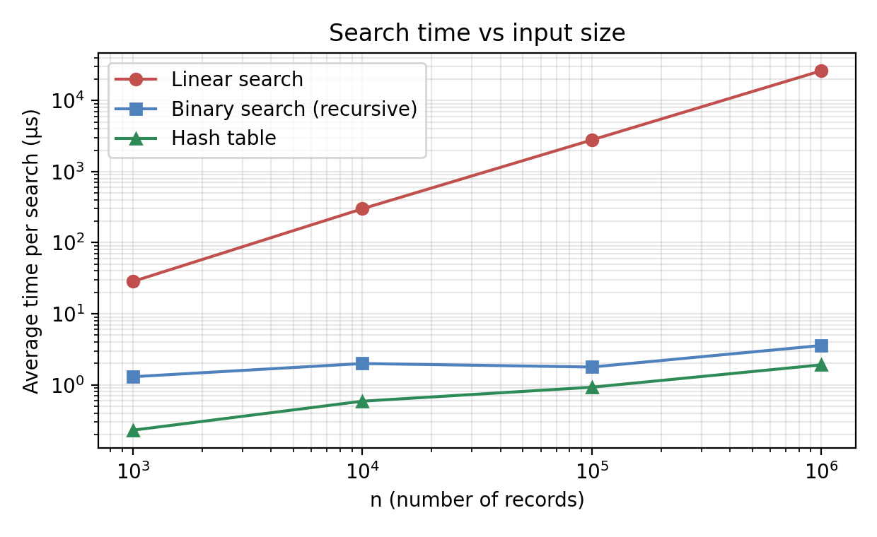
Figure 1 – Average search time vs n (log–log)
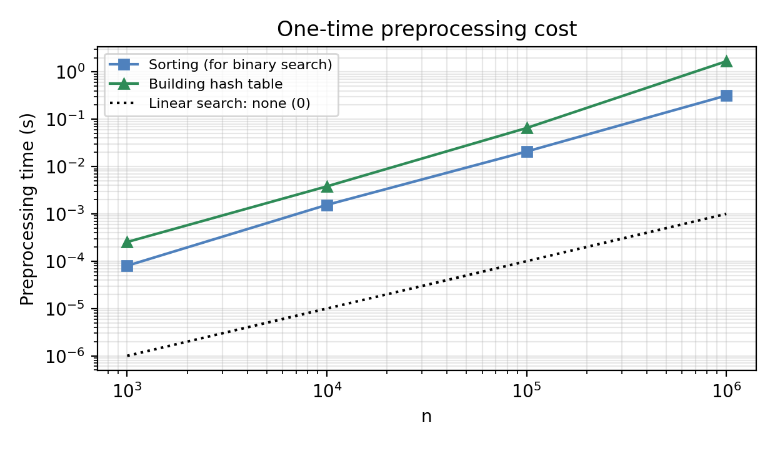
Figure 2 – One-time preprocessing cost vs n
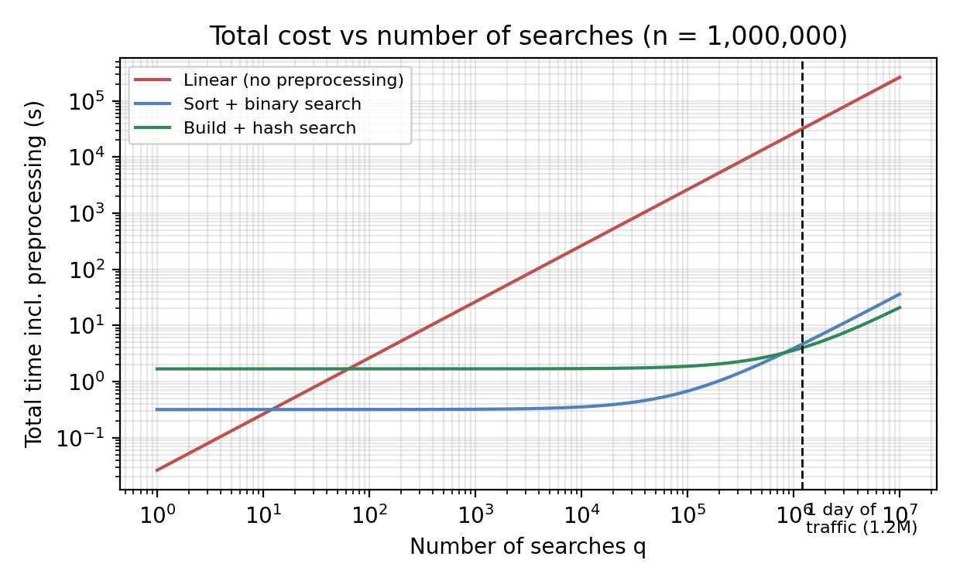
Figure 3 – Total time (preprocessing + q searches) at n = 1,000,000

Task 10 – Compare Theory with Experimental Behaviour
n | Linear: (n+1)/2 vs measured | Binary: log₂n − 1 vs measured | Hash present: 1+α/2 vs measured | Hash absent: α vs measured | Binary worst: theory / meas.
1,000 | 500.5 | 505.9 | 8.97 | 8.97 | 1.50 | 1.56 | 0.99 | 1.00 | 10 / 10
10,000 | 5,000.5 | 4,709.0 | 12.29 | 12.32 | 1.50 | 1.50 | 1.00 | 1.11 | 14 / 14
100,000 | 50,000.5 | 51,549.8 | 15.61 | 15.79 | 1.50 | 1.56 | 1.00 | 0.99 | 17 / 17
1,000,000 | 500,000.5 | 506,470.2 | 18.93 | 18.91 | 1.50 | 1.52 | 1.00 | 0.97 | 20 / 20
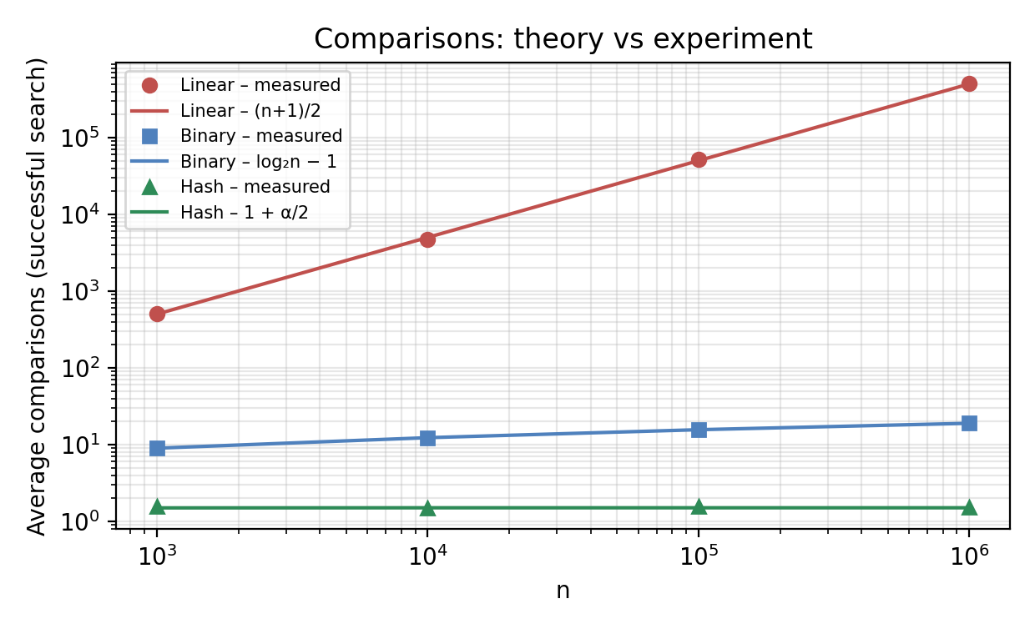
Figure 4 – Average comparisons: theory vs experiment
Does observed growth agree with the theory?
- Linear: comparison counts follow (n+1)/2 (largest deviation 5.8%, due to sampling 200 random keys) and n for absent keys. Time per search grows about 9.3× and 9.4× for the last two 10× steps in n – linear growth, Θ(n).
- Binary search: worst-case counts equal ⌊log₂ n⌋ + 1 exactly (10, 14, 17, 20); the average matches log₂ n − 1 within 0.18 comparisons. Time grows from 1.30 µs to 3.58 µs for a 1,000× larger n – logarithmic, Θ(log n).
- Hash table: average comparisons are ≈ 1.5 (present) and ≈ 1.0 (absent) at every size, within 0.06 and 0.11 of 1 + α/2 and α, confirming Θ(1) expected behaviour independent of n. The longest chain stays tiny (5 at n = 1,000 and 9 at n = 10⁶).
Which scales best? Hash table (flat), then binary search (+1 comparison per doubling), then linear search (proportional to n).
Differences between prediction and execution, and reasons
- Preprocessing: sorting grew 15.2× from n = 10⁵ to 10⁶ (theory for n log n: 12.0×) and the hash build grew 25.7× (theory for Θ(n): 10×). The extra growth comes from memory/cache effects once the data no longer fits in cache and from allocating one Python list per chain.
- Wall-clock vs operation count: by operation count, building the hash table (n insertions) is cheaper than sorting (≈ n log₂ n comparisons), but measured, the build took 1.68 s against 0.32 s for sorting. The reason is implementation, not theory: Python's sort runs in compiled C code, whereas the table is built by an interpreted loop.
- Hash search is 1.9× faster than binary search at n = 10⁶ in time, a much smaller gap than the ≈ 12× difference in comparisons, because each search also pays fixed interpreter costs (function call, hashing, indexing) that do not depend on the number of comparisons.
- Timing noise at small n (microsecond scale) and the recursive-vs-iterative difference are within normal measurement variation; recursion's real cost is stack space (Θ(log n)) rather than time.

Task 11 – Recommend and Defend the Final Design
Recommendation (original design): store the registration numbers in a sorted array and use binary search (deployed in its iterative form to save stack space; analysed in its recursive form). Records are sorted once as preprocessing.
Criterion (n = 10⁶) | Linear | Binary search | Hash table
Preprocessing | none | 0.317 s, Θ(n log n) | 1.679 s, Θ(n)
Comparisons / search (avg) | 506,470 | 18.9 | 1.52
Time / search | 26.27 ms | 3.58 µs | 1.91 µs
Worst case | Θ(n) | Θ(log n) guaranteed | Θ(n) in theory
Extra memory | Θ(1) | Θ(1) (iterative) | Θ(n)
Ordered output / ranges | No | Yes | No
Keeps working as n grows | No | Yes | Yes

- Why better than linear search: preprocessing is repaid after only about 2 log₂ n ≈ 40 searches (Task 3); after that every search is about 7,349× faster (26.27 ms vs 3.58 µs measured).
- Why chosen over the hash table at this stage: the guaranteed Θ(log n) worst case, no extra memory, sorted data that also supports ordered listings and range queries, and a much cheaper build in practice (sorting took 0.32 s against 1.68 s). Hash search is faster per query, but when the number of searches is not known, the extra preprocessing and memory of the hash table are not justified by the evidence.
- Theoretical efficiency: Θ(n log n) once + Θ(log n) per search; 20 comparisons at 10⁶ records.
- Experimental performance: 3.58 µs per search at n = 10⁶, worst case 20 comparisons, as predicted.
- Trade-offs and limitations: the array must stay sorted, so adding records requires re-sorting or merging; the sort is a one-time cost that grows as n log n.
- Scalability: practical far beyond 10⁶ records: 10⁹ records would need only 30 comparisons. The preprocessing, not the search, is what grows.

Task 12 – Day-4 Design Challenge: Re-evaluate and Adapt the Design
Changed requirement: 50,000 searches per hour on 1,000,000 records; new records added once per day.

A. Impact Analysis (2 marks)
- What changed: the workload is now defined. 50,000 searches/hour = 13.89 per second = 1,200,000 searches per day, i.e. every record is looked up more than once a day on average, while the data changes only once in 24 hours.
- Assumptions affected: (1) in the original problem the number of searches was unspecified, so the preprocessing cost had to be weighed against few searches; (2) it was implicitly assumed that the data might change at any time, so keeping sorted order looked expensive; (3) per-search cost was judged individually, whereas now it accumulates over more than a million searches per day.
- Why search frequency matters: total work = preprocessing + (number of searches × cost per search). With q = 1.2 million per day the per-search cost dominates: a difference of 1 µs per search is 1.2 s per day, and 1 ms is 20 minutes of CPU per day.
- Why rare updates matter: the data is static for 24 hours, so a structure that is expensive to build or to update but cheap to query is ideal: the build/update cost is spread over about 1.2 million searches (amortised), and no search ever has to wait for a rebuild if updates are done in one nightly batch.

B. Evaluation of the Original Design (2 marks)
- Behaviour under 50,000 searches/hour: binary search needs 3.58 µs per search, so one core could serve 279,715 searches/s against the 13.89 required (20,139× headroom); the hour's work uses only 0.005% of one core. The original design therefore still meets the requirement easily. Linear search, for comparison, takes 26.27 ms per search: capacity 38 searches/s (only 2.7× the load), 8.8 CPU-hours per day, and it would fail at about 10× more records or traffic.
- Is the preprocessing cost acceptable? The initial sort (0.32 s) is trivial. But if the sorted array is rebuilt by a full re-sort each night, it costs about 270 ms per day; this is acceptable but unnecessary, since the existing array is already sorted. Sorting only the new batch and merging costs 49–79 ms for 1,000–50,000 new records (Θ(n + k)).
- Could another approach perform better overall? Yes – the hash table. It needs 1.52 comparisons per search against 18.9 (≈ 12× fewer), 1.91 µs against 3.58 µs, and nightly insertion of new records costs only Θ(k): 0.8, 8.4 and 34.1 ms for 1,000, 10,000 and 50,000 records against 49–79 ms for the merge. Its drawbacks are the one-time build (1.68 s, repaid after about 818,174 searches – less than one day of traffic), Θ(n) extra memory and the loss of sorted order.

C. Adaptation or Redesign (2 marks)
Decision: REDESIGN – use a hash table (separate chaining) as the primary search structure. Binary search on the sorted array is kept only as a fallback/secondary index if ordered listings or range queries are ever required.
- Revised strategy: build the table once (Θ(n)); each search computes h(k) = k mod m and walks one short chain; every night the new records are inserted into their chains (Θ(k)); if the load factor exceeds a threshold (e.g., α > 2) the table is rebuilt with a larger prime m (amortised Θ(1) per insertion). Updates are applied in a nightly batch, and the new table version replaces the old one, so searches are never blocked.
- What changed: transform-and-conquer replaces decrease-and-conquer; search is no longer comparison-based over an ordered sequence; the preprocessing target is a hash table instead of a sorted array; and the daily update is an insertion batch instead of a re-sort/merge.
Complexity | Original (sorted array + binary) | Redesign (hash table)
Search (average) | Θ(log n) | Θ(1) expected
Search (worst) | Θ(log n) | Θ(n) pathological; longest chain observed: 9
Initial preprocessing | Θ(n log n) | Θ(n)
Daily update of k records | Θ(n + k) merge | Θ(k) insertions
Extra memory | Θ(1) | Θ(n)
Total per day (q searches + update) | Θ(q log n + n + k) | Θ(q + k)

D. Evidence-Based Defence (2 marks)
Evidence (n = 10⁶, 1.2 M searches/day) | Linear | Binary | Hash
Comparisons per search | 506,470 | 18.9 | 1.52
Measured time per search | 26.27 ms | 3.58 µs | 1.91 µs
Capacity (1 core) | 38 /s | 279,715 /s | 523,507 /s
Required rate | 13.89 /s | 13.89 /s | 13.89 /s
Search CPU per day | 8.8 h | 4.3 s | 2.3 s
Preprocessing (once) | 0 | 0.32 s | 1.68 s
Nightly update, 10,000 new records | append | 50 ms (merge) | 8.4 ms (insert)
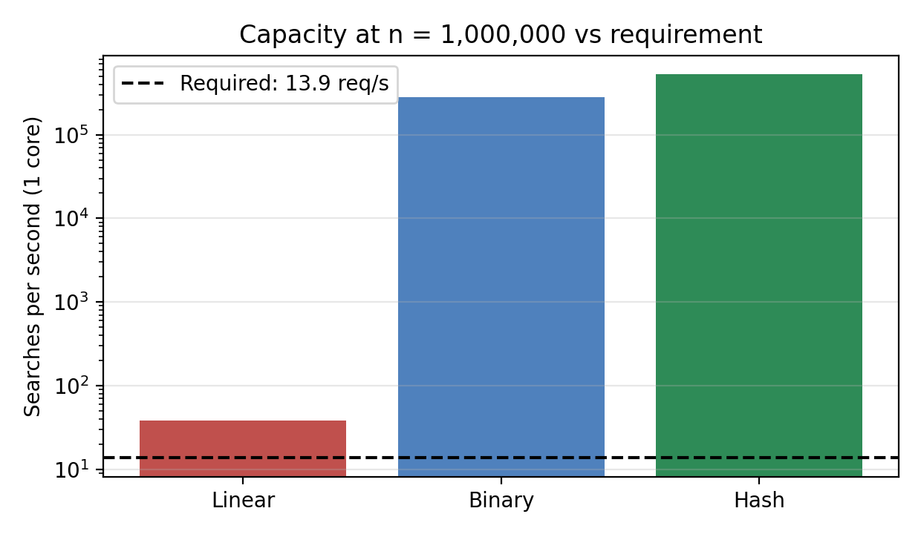
Figure 5 – Capacity of one core vs the required rate
- Complexity analysis: Θ(n) per search is a poor fit for 1.2 million searches a day (linear search: 8.8 CPU-hours daily, about 36% of a core, and no headroom at 10× growth); Θ(log n) is sufficient; Θ(1) expected is best and independent of database size.
- Search frequency and preprocessing: with 1,200,000 searches a day the one-time 1.68 s build is amortised to 1.40 µs per search, smaller than the 1.66 µs per search it saves relative to binary search. Because updates occur only once per day, insertion cost is irrelevant to latency.
- Dataset size: the redesign's per-search cost does not grow with n, whereas binary search adds one comparison per doubling; the hash structure is therefore the safer choice if the database grows beyond 10⁶ records.
- Honest assessment of trade-offs: both binary search and hashing meet the requirement by a margin of more than 20,000×, so the redesign is not forced by capacity; it is justified by lower asymptotic cost, cheaper nightly updates and independence from n. If the university needed ordered listings, range queries (e.g., all registration numbers of one batch) or minimal memory, retaining the sorted array and merging the nightly batch (a MODIFY decision) would be equally defensible. For the stated requirement – exact-match lookup of a registration number – the hash table is the better design.
Final decision: redesign to a chained hash table; linear search rejected because its Θ(n) cost uses about a third of a core and cannot absorb growth; binary search retained as a fallback index.

Appendix A – Source Code (search_algorithms.py)
"""
CO1 Assignment - Searching student registration numbers
Approaches: (1) Linear search, (2) Iterative binary search, (3) Recursive binary search
Every function returns (index, comparisons). One key comparison = one "basic operation".
"""
import random, time, json, math, sys

sys.setrecursionlimit(10000)

# ---------------- Algorithms ----------------
def linear_search(a, key):
comps = 0
for i in range(len(a)):
comps += 1 # basic operation: a[i] == key
if a[i] == key:
return i, comps
return -1, comps

def binary_iterative(a, key):
low, high, comps = 0, len(a) - 1, 0
while low <= high:
mid = (low + high) // 2
comps += 1 # basic operation: key vs a[mid] (3-way)
if a[mid] == key:
return mid, comps
elif key < a[mid]:
high = mid - 1
else:
low = mid + 1
return -1, comps

def binary_recursive(a, key, low=0, high=None, comps=0):
if high is None:
high = len(a) - 1
if low > high:
return -1, comps
mid = (low + high) // 2
comps += 1 # basic operation: key vs a[mid] (3-way)
if a[mid] == key:
return mid, comps
if key < a[mid]:
return binary_recursive(a, key, low, mid - 1, comps)
return binary_recursive(a, key, mid + 1, high, comps)

# ---- Approach 3: hash table with separate chaining (transform-and-conquer / space-time trade-off) ----
def next_prime(x):
def is_p(v):
if v < 2: return False
i = 2
while i * i <= v:
if v % i == 0: return False
i += 1
return True
while not is_p(x):
x += 1
return x

def build_hash(a):
"""Preprocessing: insert every record; table size m = prime >= n; h(k) = k mod m."""
m = next_prime(max(len(a), 2))
table = [[] for _ in range(m)]
for i, k in enumerate(a):
table[k % m].append((k, i))
return table, m

def hash_insert(table, m, key, value):
table[key % m].append((key, value))

def hash_search(table, m, key):
comps = 0
for k, v in table[key % m]: # walk the chain
comps += 1 # basic operation: key comparison inside the chain
if k == key:
return v, comps
return -1, comps

# ---------------- Data ----------------
def make_data(n, seed=42):
rnd = random.Random(seed)
regs = rnd.sample(range(100_000_000, 999_999_999), n) # unique 9-digit Reg. Nos.
unsorted = regs[:] # arrival order (for linear search)
return unsorted, sorted(regs)

# ---------------- Test cases ----------------
def run_tests():
results = []
data = [3, 8, 15, 21, 34, 42, 57, 63, 79, 90]
cases = [
("First element", data, 3),
("Middle element", data, 34),
("Last element", data, 90),
("Key absent (small)", data, 1),
("Key absent (middle)", data, 40),
("Key absent (large)", data, 100),
("Single element - found", [7], 7),
("Single element - absent", [7], 9),
("Empty list", [], 5),
]
ok = True
for name, arr, key in cases:
expected = arr.index(key) if key in arr else -1
row = [name, key]
case_ok = True
tb, tm = build_hash(arr)
for f in (lambda a_, k_: linear_search(a_, k_),
lambda a_, k_: binary_recursive(a_, k_),
lambda a_, k_: hash_search(tb, tm, k_)):
idx, c = f(arr, key)
case_ok &= (idx == expected)
row += [idx, c]
ok &= case_ok
row.append("PASS" if case_ok else "FAIL")
results.append(row)
# randomized cross-check
rnd = random.Random(1)
for _ in range(2000):
arr = sorted(rnd.sample(range(1000), rnd.randint(0, 60)))
key = rnd.randint(0, 1000)
exp = arr.index(key) if key in arr else -1
assert linear_search(arr, key)[0] == exp
assert binary_iterative(arr, key)[0] == exp
assert binary_recursive(arr, key)[0] == exp
tb, tm = build_hash(arr)
assert hash_search(tb, tm, key)[0] == exp
return results, ok

# ---------------- Experiments ----------------
def experiment(sizes, trials=200):
out, pre = {}, {}
for n in sizes:
unsorted, _ = make_data(n)
# ---- preprocessing (timed, best of 3) ----
ts = []
for _ in range(3):
t0 = time.perf_counter(); srt = sorted(unsorted); ts.append(time.perf_counter() - t0)
th = []
for _ in range(3):
t0 = time.perf_counter(); table, m = build_hash(unsorted); th.append(time.perf_counter() - t0)
chain = [len(b) for b in table]
pre[n] = dict(sort_s=min(ts), hash_s=min(th), m=m, alpha=n / m, max_chain=max(chain),
empty=sum(1 for c in chain if c == 0) / m)
rnd = random.Random(n)
hits = rnd.sample(srt, min(trials, n))
present = set(srt); misses = []
while len(misses) < trials:
k = rnd.randint(100_000_000, 999_999_999)
if k not in present: misses.append(k)
algos = (("linear", lambda k: linear_search(unsorted, k)),
("binary_iter", lambda k: binary_iterative(srt, k)),
("binary_rec", lambda k: binary_recursive(srt, k)),
("hash", lambda k: hash_search(table, m, k)))
rec = {}
for name, f in algos:
if name == "linear":
best, worst = f(unsorted[0])[1], f(unsorted[-1])[1]
elif name == "hash":
best = 1
longest = max(table, key=len)
worst = f(longest[-1][0])[1] # last key of the longest chain
else:
best = f(srt[(n - 1) // 2])[1]
worst = max(f(k)[1] for k in misses)
t0 = time.perf_counter(); hc = [f(k)[1] for k in hits]
t_hit = (time.perf_counter() - t0) / len(hits)
t0 = time.perf_counter(); mc = [f(k)[1] for k in misses]
t_miss = (time.perf_counter() - t0) / len(misses)
rec[name] = dict(best=best, worst=worst, avg_hit=sum(hc)/len(hc), avg_miss=sum(mc)/len(mc),
t_hit_us=t_hit*1e6, t_miss_us=t_miss*1e6)
out[n] = rec
print(f"n={n:>9,} done", flush=True)
return out, pre

def daily_update_times(n, k):
"""Cost of adding k new records once per day, n = 1,000,000 existing records."""
unsorted, srt = make_data(n)
rnd = random.Random(7)
new = rnd.sample(range(1, 99_999_999), k) # new reg. numbers (disjoint range)
t0 = time.perf_counter(); sorted(unsorted + new); t_resort = time.perf_counter() - t0 # full re-sort
t0 = time.perf_counter(); sorted(srt + sorted(new)); t_merge = time.perf_counter() - t0 # sort batch + merge
table, m = build_hash(unsorted)
t0 = time.perf_counter()
for i, key in enumerate(new): hash_insert(table, m, key, n + i)
t_hins = time.perf_counter() - t0
return t_resort, t_merge, t_hins, (n + k) / m

if __name__ == "__main__":
print("=" * 70); print("TEST CASES"); print("=" * 70)
rows, ok = run_tests()
print(f"{'Test case':26s}{'Key':>5s} | {'Linear(idx,c)':>13s} | {'BinRec(idx,c)':>13s} | {'Hash(idx,c)':>11s} | Result")
for r in rows:
print(f"{r[0]:26s}{r[1]:>5} | {r[2]:>7},{r[3]:>4} | {r[4]:>7},{r[5]:>4} | {r[6]:>5},{r[7]:>4} | {r[8]}")
print("2000 randomized cross-checks of all approaches (incl. iterative binary variant): PASSED")
print("All fixed test cases:", "PASS" if ok else "FAIL")

print("\n" + "=" * 70); print("EXPERIMENTS"); print("=" * 70)
sizes = [1_000, 10_000, 100_000, 1_000_000]
res, pre = experiment(sizes)
print("\nPREPROCESSING COST")
print(f"{'n':>10s}{'sort (s)':>12s}{'hash build (s)':>16s}{'table size m':>14s}{'load a=n/m':>12s}{'max chain':>11s}")
for n in sizes:
p = pre[n]
print(f"{n:>10,}{p['sort_s']:>12.4f}{p['hash_s']:>16.4f}{p['m']:>14,}{p['alpha']:>12.3f}{p['max_chain']:>11}")
for n in sizes:
r = res[n]
print(f"\nn = {n:,} (log2 n = {math.log2(n):.2f})")
print(f"{'Algorithm':14s}{'Best':>6s}{'Worst':>9s}{'AvgHit':>12s}{'AvgMiss':>12s}{'t_hit(us)':>12s}{'t_miss(us)':>12s}")
for name in ("linear", "binary_rec", "binary_iter", "hash"):
x = r[name]
print(f"{name:14s}{x['best']:>6}{x['worst']:>9}{x['avg_hit']:>12.2f}{x['avg_miss']:>12.2f}{x['t_hit_us']:>12.2f}{x['t_miss_us']:>12.2f}")

print("\n" + "=" * 70); print("DAY-4 DESIGN CHALLENGE: daily update of 1,000,000 records"); print("=" * 70)
upd = {}
print(f"{'new k':>8s}{'full re-sort (ms)':>20s}{'sort batch+merge (ms)':>24s}{'hash insert k (ms)':>20s}")
for k in (1_000, 10_000, 50_000):
a, b, c, al = daily_update_times(1_000_000, k)
upd[k] = dict(resort=a, merge=b, hins=c, alpha=al)
print(f"{k:>8,}{a*1000:>20.1f}{b*1000:>24.1f}{c*1000:>20.1f}")

json.dump({"tests": rows, "res": {str(k): v for k, v in res.items()},
"pre": {str(k): v for k, v in pre.items()}, "upd": {str(k): v for k, v in upd.items()}},
open("results.json", "w"))

Appendix B – Program Output
======================================================================
TEST CASES
======================================================================
Test case Key | Linear(idx,c) | BinRec(idx,c) | Hash(idx,c) | Result
First element 3 | 0, 1 | 0, 3 | 0, 1 | PASS
Middle element 34 | 4, 5 | 4, 1 | 4, 1 | PASS
Last element 90 | 9, 10 | 9, 4 | 9, 3 | PASS
Key absent (small) 1 | -1, 10 | -1, 3 | -1, 1 | PASS
Key absent (middle) 40 | -1, 10 | -1, 3 | -1, 0 | PASS
Key absent (large) 100 | -1, 10 | -1, 4 | -1, 1 | PASS
Single element - found 7 | 0, 1 | 0, 1 | 0, 1 | PASS
Single element - absent 9 | -1, 1 | -1, 1 | -1, 1 | PASS
Empty list 5 | -1, 0 | -1, 0 | -1, 0 | PASS
2000 randomized cross-checks of all approaches (incl. iterative binary variant): PASSED
All fixed test cases: PASS

======================================================================
EXPERIMENTS
======================================================================
n= 1,000 done
n= 10,000 done
n= 100,000 done
n=1,000,000 done

PREPROCESSING COST
n sort (s) hash build (s) table size m load a=n/m max chain
1,000 0.0001 0.0003 1,009 0.991 5
10,000 0.0016 0.0038 10,007 0.999 7
100,000 0.0208 0.0653 100,003 1.000 8
1,000,000 0.3169 1.6791 1,000,003 1.000 9

n = 1,000 (log2 n = 9.97)
Algorithm Best Worst AvgHit AvgMiss t_hit(us) t_miss(us)
linear 1 1000 505.92 1000.00 16.35 40.55
binary_rec 1 10 8.96 9.99 1.42 1.18
binary_iter 1 10 8.96 9.99 1.06 1.31
hash 1 5 1.56 1.00 0.28 0.18

n = 10,000 (log2 n = 13.29)
Algorithm Best Worst AvgHit AvgMiss t_hit(us) t_miss(us)
linear 1 10000 4709.02 10000.00 154.76 445.12
binary_rec 1 14 12.32 13.38 2.28 1.70
binary_iter 1 14 12.32 13.38 1.24 2.70
hash 1 7 1.50 1.11 0.71 0.47

n = 100,000 (log2 n = 16.61)
Algorithm Best Worst AvgHit AvgMiss t_hit(us) t_miss(us)
linear 1 100000 51549.79 100000.00 2050.16 3528.10
binary_rec 1 17 15.79 16.69 1.78 1.78
binary_iter 1 17 15.79 16.69 2.33 1.40
hash 1 8 1.56 0.99 1.22 0.63

n = 1,000,000 (log2 n = 19.93)
Algorithm Best Worst AvgHit AvgMiss t_hit(us) t_miss(us)
linear 1 1000000 506470.24 1000000.00 18435.79 34110.81
binary_rec 1 20 18.91 19.96 3.89 3.26
binary_iter 1 20 18.91 19.96 5.66 4.40
hash 1 9 1.52 0.97 2.16 1.66

======================================================================
DAY-4 DESIGN CHALLENGE: daily update of 1,000,000 records
======================================================================
new k full re-sort (ms) sort batch+merge (ms) hash insert k (ms)
1,000 306.7 48.5 0.8
10,000 269.8 49.8 8.4
50,000 332.5 78.7 34.1

Appendix C – Repository Structure and README
CO1_Assignment/
|-- Task_1_Algorithm_Design/ ... Task_7_Recurrence_Solution/ (one folder per task; copy the matching section)
|-- Task_8_Implementation_Testing/Source_Code/search_algorithms.py
|-- Task_9_Experimental_Performance/ (tables, g_time.png, g_pre.png, g_total.png)
|-- Task_10_Theory_vs_Experiment/ (g_comps.png)
|-- Task_11_Final_Recommendation/
|-- Task_12_Design_Challenge/ (g_capacity.png)
|-- Report/
| |-- Source_Code_Screenshots/ |-- Output_Screenshots/ |-- Analysis/
| |-- Tables_and_Graphs/ `-- Documentation/ (this report)
`-- README.md
README.md: Project – efficient search of student registration numbers; algorithms: linear search, binary search (recursive; iterative variant) and chained hash table; analysis: operation counts, case analysis, recurrence T(n) = T(⌊n/2⌋) + 1, asymptotics; experiments for n = 1,000 – 1,000,000 including preprocessing; Design Challenge decision (hash-table redesign). Run: python search_algorithms.py (Python 3.8+, no external libraries); python charts.py regenerates the graphs (needs matplotlib).

